Tevyah Hanley
3-8-26
Assignment 10.2

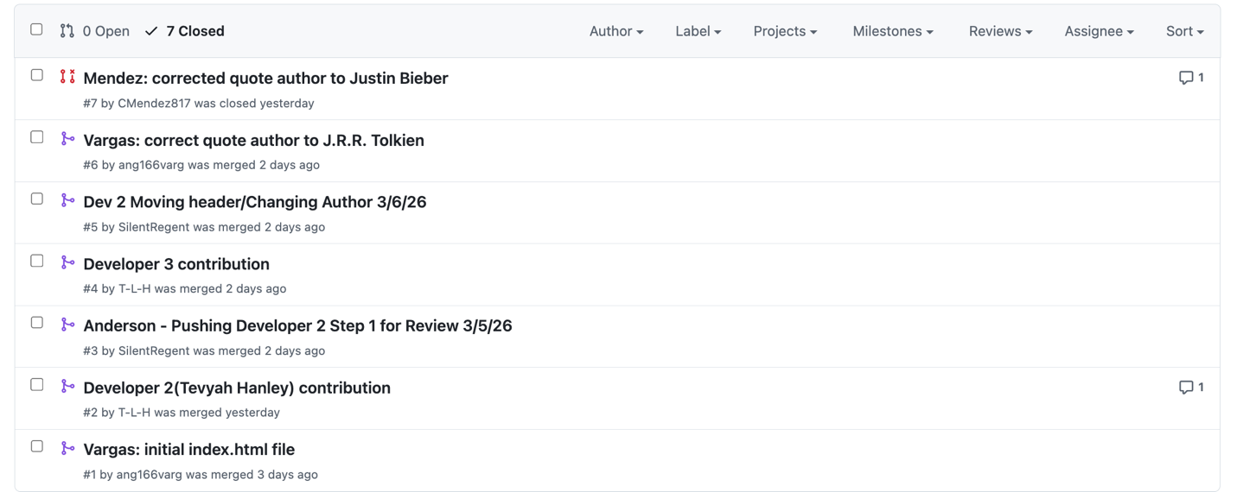
https://github.com/ang166varg/GitLab
Username: T-L-H

